VII th Kadet & Junior ITF
Open Croatian Championships

7th MARSONIA OPEN 2006.

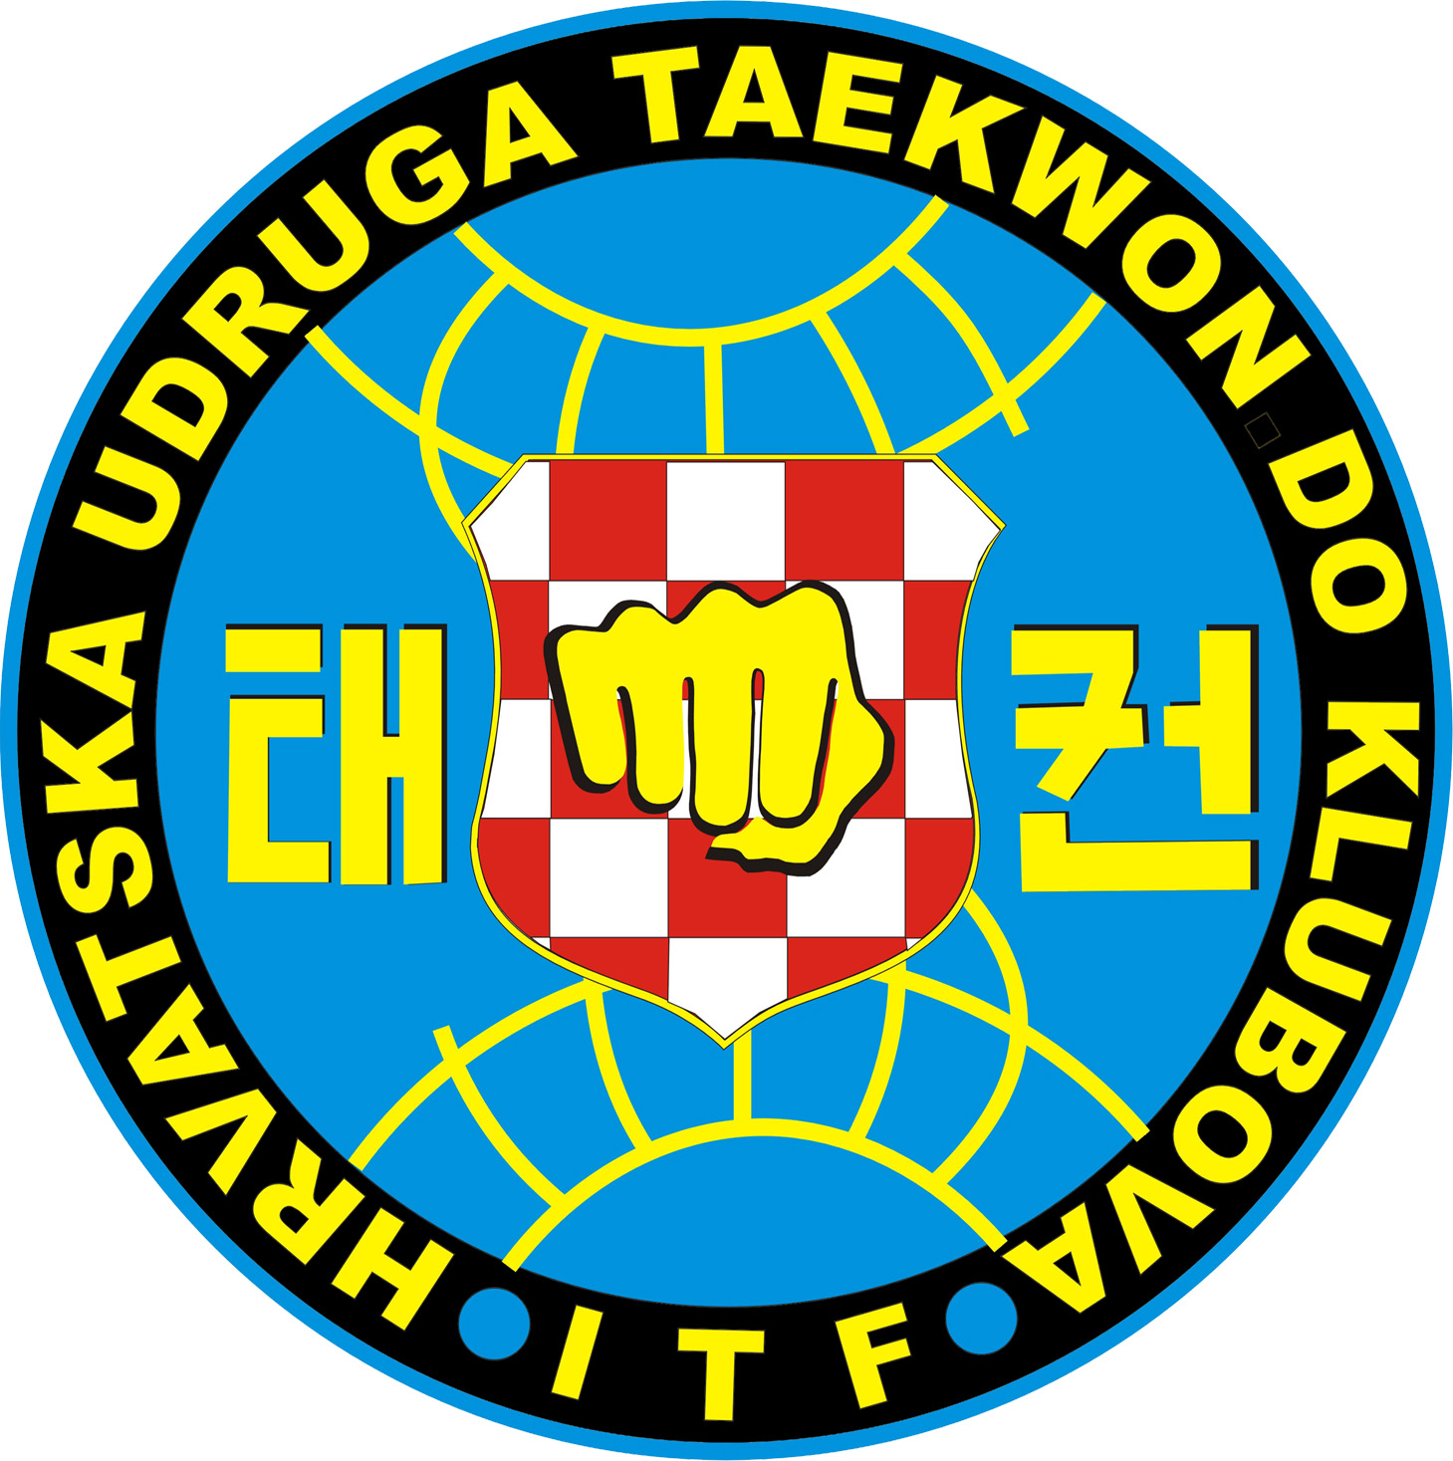

OFFICIAL INFORMATION

Slavonski Brod, Croatia
18th March, 2006

