I N T E R N A T I O N A L T A E K W O N- D O F E D E R A T I O N I.T.F
TAEKWON-DO KLUB „SOKO“
Nikola Tesla 13
24300 Bačka Topola
SRBIJA
www.itfsoko.org.yu

e-mail: itfsoko@hotmail.com
tel/fax: + 381 24 711 716

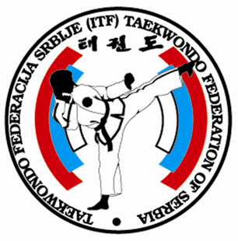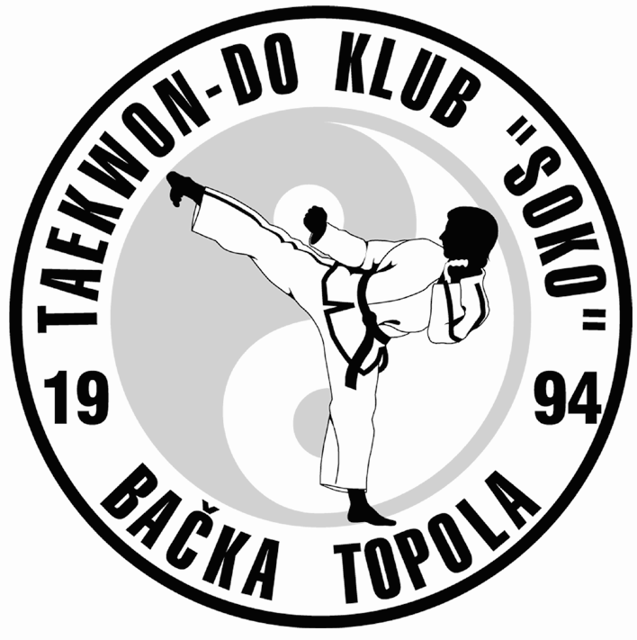

žiro-račun: 355-1031672-91; Vojvođanska banka, filijala: Bačka Topola

INVITATION
TO INTERNATIONAL
ITF
TAEKWON-DO TOURNAMENT,

Xth ITF TAEKWON-DO CUP OF SERBIA AND MONTENEGRO
BAČKA TOPOLA, SERBIA
22.04.2006.
Dear presidents,
Officials,
Instructors
And fellow competitors,

We are honored, to invite you to an international tournament of
Xth ITF TAEKWON-DO CUP OF SERBIA AND MONTENEGRO
which will be held in Bačka Topola – Serbia on 22th April 2006

IMPORTANT INFORMATION

DATE and PLACE: Saturday 22th April 2006; Bačka Topola, sport hall “Čaki Lajoš”, st. Omladinska bb, 24300 Bačka Topola

ORGANIZER: Taekwon-do Club “SOKO” Bačka Topola and ITF Taekwon-do Federation of Serbia

REGISTRATION-FEE: 15 EUR

NOTIFICATION: UP TO WEDNESDAY 12rd April 2006; FAX: 00381 24 711 716,
E -mail:
➢ itfsoko@hotmail.com

REFEREES: It is necessary to wear a suit (blue pants, white shirt, blue coat, blue tie, sneakers).
Every club has to provide at least one referee, otherwise a penalty in amount of 50 EUR will have to be paid on the day of the competition

RULES: Rules and regulations of ITF
Each competitor has to wear dobok and appropriate equipment.

DRAW: 21rd April 2006 AT 18h - HEADQUARTERS OF TKD KLUB SOKO

GENERAL REFEREE: mr. Nenad Vrekić V DAN

COACHES: Coaches have to take in to consideration instructions of organizers and wear – sports suit and sneakers

SPARING: ( boys and girls up to 14 years ) 1992 AND YOUNGER:

BOYS : -25kg, -30kg, -35kg, -40kg, -45kg, -50kg, -55kg, +55kg
GIRLS: -25kg, -30kg, -35kg, -40kg, -45kg, -50kg, -55kg, +55kg

JUNIORS UP TO 18 YEARS

MALE: -45kg , -51kg , -57kg, -63kg, -69kg, -75kg, +75kg
FEMALE: -40kg , -46kg , -52kg , -58kg , -64kg, -70kg,+70kg

SENIORS 1988 AND OLDER

MALE: -50kg, -57kg, -64kg, -71kg, -78kg,-85kg +85kg
FEMALE: -45kg, -51kg, -57kg, -63kg, -69kg, -75kg, +75kg

TUL/PATTERNS: YELLOW BELT,8 – 7 KUP: CHON JI – DAN GUN
GREEN BELT, 6 – 5 KUP: CHON JI – WON HYO
BLUE BELT, 4 – 3 KUP: CHON JI – JOONG GUN
RED BELT, 2 – 1 KUP: CHON JI – HWA RANG
BLACK BELT, I. Dan, CHON JI – GE BAEK
BLACK BELT, II.Dan, CHON JI – JU CHE
BLACK BELT, III.Dan, CHON JI – CHOI YONG

In qualifications From the Jury designated Tull.
In finals First Tull is on competitor′s choice, second from the Jury designated Tull.

COMPLAINTS: Before giving a complaint in written form to jury president, you have to pay 50 eur at the latest 3 minutes after the finished match

WEIGHTING: FRIDAY 21st April 2006 from 19.00h – 22.00h in headquarters of TKD SOKO
SATURDAY 22.04.2006 OD 7.00 h – 8:30h in sport hall “Čaki Lajoš”, st. Omladinska bb

REWARDS: 1, 2 , 3 , 3 place, medals and diplomas

Special awards and money prizes for:
- 1st, 2nd and 3rd ″BEST CLUB″ (points are collected: 1st place - 3 points, 2nd place - 2 points and 3rd place - 1 point from sparring and patterns)

TIME OF SPARING: QUALIFICATIONS 1 X 2 MIN. FINALS 2 X 2 MIN.

WARNING: ORGANIZER WILL TAKE NO RESPONSIBILITY IN CASE OF INJURY ON THE TOURNAMENT. EACH COMPETITOR WILL COMPETE ON HIS OWN RISK

CHANGES: CHANGE OF CATEGORY ON THE DAY OF THE COMPETITION IS NOT POSIBLE!!! IF ON THE WEIGHTING IS ESTABLISHED THAT COMPETITOR IS OVER HIS CATEGORY HE/SHE WILL BE DISQUALIFIED, UNLESS PAYMENT PER COMPETITOR (20 EUR) IS PAID ONCE AGAIN.

SCHEDULE: SATURDAY, 04.02.2006
7: 00 – 8: 30 WEIGHTING
8: 30 – 9: 00 EXTRA DRAW
9: 00 – 9: 30 MEETING OF REFEREES AND COACHES
9: 30 – 10:00 OPENING CEREMONY
10:00 QUALIFICATIONS
13:30 – 14:00 LUNCH BRAKE
14:00 – 17:00 QUALIFICATIONS
17:00 – 18:00 FINAL FIGHTS

ACCOMODATION : HOTEL “Biser” Panonija, Hotel “Jadran” Zobnatica, Lovački dom “Dijana” Stara Moravica, Lovački dom Bajša, Lovački dom “Capryolo” B. Topola, Motel “Ciha” Bačka Topola, Hotel “Panonija” Bačka Topola.

CONTACT PERSONS: Nenad Vrekić V DAN tel:+ 381 63 220 072
+ 381 63 550 704

Marinko Stojaković III DAN tel. + 381 64 309 6 009
Suzana Vrekić I DAN tel. + 381 63 528 274
http// www.itfsoko.org.yu e-mail: itfsoko@hotmail.com

On this years tournament we expect also schools from BULGARIA, GREECE, HUNGARY, SLOVENIA, BOSNIA AND HERZEGOVINA, REPUBLIC OF SRPSKA, CROATIA, CZEH REPUBLIC, AUSTRIA, HOLAND, FRANCE AND SERBIA AND MONTENEGRO.

WE ARE LOOKING FORWARD TO SEE YOU SOON AND HEARING FROM YOU!!!

ENTRY FORM:
Name of club: ______________ _______________________________________
Adress: _____________________ _______________________________________
Country: _______________________ _______________________________________
Coach and contact person:___ ______________Email: ________________
Phone number:_________________________Fax:_______________________________
AGE CATEGORY_________________________________________SEX: __________
N° | First and last name | Year  of birth | Grade | Weight | Tull | Sparring

REFEREE |  | Degree
REFEREE |  | Degree

