

1st ITF Youth Taekwon-do Europe Cup

Date: Saturday-Sunday May 03-04, 2003
Place: Zoltán Kodály School Sports hall, Hatvan, Hungary (map enclosed)
Organizer: Hatvani Taekwon-Do Club, Member of ITF Hungary
Head referee: Master László Harmat VII degree

Competition entry fees: 15.00 Euro if a competitor will participate only at Sparring OR Patterns
20.00 Euro if a competitor will participate at both

Entry fee to the sports hall: 2.00 Euro, only for visitors/friends etc.. Competitors, coaches, umpires: free of charge.

Entry divisions: Girls and boys 8-18 years and minimum 8th grade
(8. gup yellow belt)

Age classes:
Youth: Up to the age of 14 if not exceeded on the day of the Competition
Junior: Up to the age of 18 if not exceeded on the day of the Competition

Weight control: Youth: Saturday 8.00-9.00 a.m.
Junior: Sunday 8.00-9.00 a.m.

Umpires: Every club must provide 1 (one) umpire (if not possible, please call the organizers). The organiser provides lunch on Saturday and Sunday. Umpires' clothing: as written in the ITF/AETF umpire rules.

Competition rules: As laid down by the A.E.T.F. rules and manuals.

Pattern categories: Youth and Junior, male and female
- 8th grade (yellow belt): Dan-gun tul
- 6-7th grade (yellow/green and green belt): Won-hyo tul
- 4-5th grade (green/blue and blue belt): Joong-gun tul
- 2-3rd grade (blue/red and red belts): Hwa-rang tul
- 1st grade-1st degree (red/black and black belt): Kwang-gae tul

Pattern finals: Tul chosen by the head of umpires, not higher
than the lower belt holder’s maximum. E.g. if there are two 1st degrees int he final, umpires could select from Chon-Ji to Ge-Baek, in case of a 1st grade (1 Gup) and a 1st degree (1 Dan) competitor in the final, umpires could select from Chon-Ji up to Kwang-Gae.

Weight categories:
Youth girls:
-30, -35, -42, -48, + 48 kg
Youth boys:
-30, -35, -40, -45, -50, -55, +55 kg
Junior girls:
-45, -50, -55, -60, + 60 kg
Junior boys:
-52, -58, -63, -70, + 70 kg

Sparring Time: Youth 1x2 minutes, Finals: 2x1,5 minutes
Junior 1x2 minutes, Finals: 2x2 minutes

Safety Equipment: as written in ITF/AETF rules. Must wear: hand and feet
safety equipment, groin guards (boys) must be worn
inside the dobok. Optional: mouth guards, head guard,
breasts protectors (girls), shin protectors.

Prizes: Cups will be awarding for a Ist-IInd-IIIrd place (for the third place
competition is required) + certification + surprise award

Program:

May 3 (Saturday) Youth
7.00 – 9.00 Registration and weight control, Youth
9.00 – 9.20 Coach and Umpire meeting
9.30 Opening ceremony
9.45 Competition: patterns incl. finals
11.00 Competition: sparring
13.00 – 14.00 Lunch-time
14.00 – 17.00 Competition: sparring incl. finals
17.00 – 17.30 Awarding, Youth
17.30 – 18.00 Closing ceremony
19.30 Meeting on the city's main square
20.00 Taekwon-Do Night
22.00 – 24.00 Street dance

May 4 (Sunday) Junior
7.00 – 9.00 Registration and weight control, Junior
9.00 – 9.20 Coach and Umpire meeting
9.30 Opening ceremony
9.45 Competition: patterns incl. finals
11.00 Competition: sparring
13.00 – 14.00 Lunch-time
14.00 – 17.30 Competition: sparring incl. finals
17.30 – 18.00 Awarding, Junior
18.00 Closing ceremony

Hotel accommodation:

Cheap category: student hostel (20 kilometres from the sports hall)
Costs 10 Eur/person/night, breakfast for 4 Eur/person/day

Hotel: 25 kilometres from the sports hall
Costs 25 Eur/person/night in rooms with 2 beds

You are asked to send your requirements of accommodation together with the application of participation.

Taekwon-Do Night
(The night program)

With this new initiation we would like to represent a high skilled Taekwon-Do show where clubs are able to show their knowledge of this art.

We would like to ask the leaders of all clubs to arrange a 8-10 minutes long stageshow accompanied by music. We are going to provide you the breaking material (wooden plate). There is going to be a mutual technical meeting about the show on Saturday.

A complete light and sound technique is going to be provided on a stage of 10x8 meters erased on the main square of the town. (Including smoke-technique and a stroboscope.)

We would like to arrange a kind of formal-show performed by the leaders of clubs for the audience. We kindly ask you to take part in this as well.

Closing of the show: Demonstration of the Hungarian National Team (adults).

Deadline of sending application forms: 14th of April 2003.
You can send your application forms by fax or email.

Information:
e-mail: vegso3@mailbox.hu
Fax: +36-37-344513
Phone help: +36-30-9548061
(Lajos Dorner, 3rd degree, ITF Hungary), taekwondo@vision.hu

Hatvan, 17th of March 2003

Yours sincerely,

Ferenc Hatvani
Organizer
Application form
youth 8-14 years

Name of Club: ________________________________________________________________
Address: ________________________________________________________________
Contact person: ________________________________________________________________
Phone: _______________________
Fax: _________________________
E-mail:_______________________
Coach: ________________________________________________________________
Umpire: ________________________________________________________________

No Name and Surname Sex Date of birth Grade Weight Tul Sparr.

Application form
junior 14-18 years

Name of Club: ________________________________________________________________
Address: ________________________________________________________________
Contact person: ________________________________________________________________
Phone: _______________________
Fax: _________________________
E-mail:_______________________
Coach: ________________________________________________________________
Umpire: ________________________________________________________________

No Name and Surname Sex Date of birth Grade Weight Tul Sparr.
Hotel reservation:

Youth hostel: No. of beds (total): ________________ _

Hotel: No. of double rooms (total): _________________

Total No. of persons, incl. Visitors, friends etc.: _______

Any speciality: call, fax or email the organizers.

Travelling:

Our team will travel by car/bus train

If you need help, call or email the organizers.

Maps if you travel by car/bus:

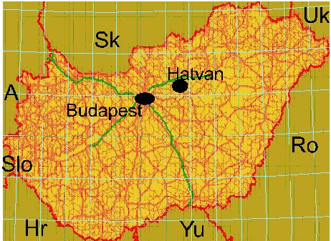

City of Hatvan is approx. 55 kms from Budapest on the M3 highway or No. 30 main road. Note: Highways in Hungary are payable. You can buy a weekly ticket at the border stations, valid for M1, M3 and M7 highways.

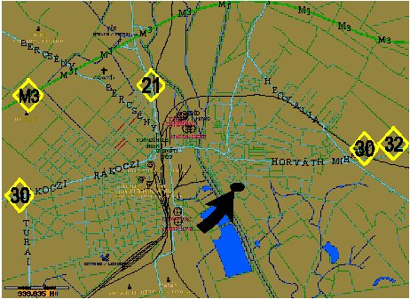

There will be direction boards int he city for your help.

