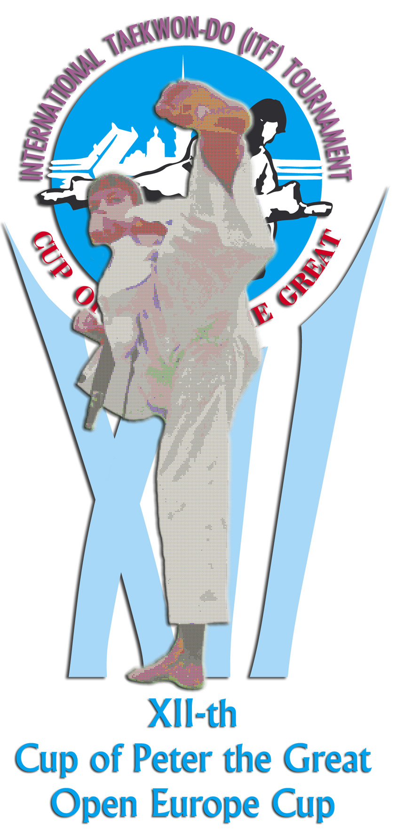

5-7 December 2003 Saint-Petersburg, Russia

Dear Sirs,
We are happy to invite you to the AETF Congress to be held on
December 5, 2003 and to the XII International Taekwon-Do (ITF)
“Cup of Peter the Great” Tournament, Open Europe Cup to be held on December 6-7, 2003 in the city of Saint-Petersburg, Russia. We will be glad to welcome your Male & Female teams in all items of the Individual & Team programme: Patterns, Sparring, Special Technique, Power Breaking.
Beside exciting bouts you will see an impressive show performed by young students of the Saint-Petersburg Taekwon-Do Federation.
You will have a chance to enjoy the “Beer Garden”, casino, billiards, auto salon, sports goods fair and other amusements.
If you are interested in participation we will provide you with detailed information.

Looking forward to seeing you in Saint-Petersburg !

Mikhail Shmelev

AETF Vice-President

President of St-Petersburg Taekwon-do Federation

Open Europe Cup 2003

Sanctioned by the AETF
XII-th International Taekwon-Do ITF Tournament
“CUP OF PETER THE GREAT”

December 6-7, 2003

G E N E R A L I N F O R M A T I O N

”Cup of Peter The Great ” will be held according to the rules of AETF considering changes and supplements of the present tournament regulations.

Accreditation and check-in of participants will be held at «Pulkovskaya» Hotel on
December 4-5, 2003 from 10.00 to 19.00. Check-in will be completed on December 5, 2003 at 19.00. Competitors should submit passports, ITF degree certificate, the application form filled by head of delegation, medical insurance.

Accommodation: “Pulkovskaya” Hotel, Pobedy sq. 1.
It is a nice hotel located ten min. drive from the international airport and the Peterburgsky Sports Centre.
The cost of accommodation per person per night sharing a Double room is $ 35 US.
Cost of a Single room is $ 59 US per night (to be paid in Russian roubles due to exchange rate on the day of payment).
Prices include breakfast (buffet) and dinner.

Place of the tournament: Peterburgsky Sports Centre, pr. Y. Gagarina 8.

Details will follow in due course or see
http://www.tornado.spb.ru/petercup/cpv12/invitat12.htm

For further information please do not hesitate to contact us.
Phone: +7 (812) 376 25 38, +7 (812) 376 15 34
Fax : +7 (812) 376 34 02, +7 (812) 153 75 15

Person in charge: Lukasheva Natalia

