APPLICATION FORM

Nitra Open 2010
April 16th – 17th, Nitra

Club:
Coach :
Accommodation – April, 16
(competitors, umpires, coaches and guests)
Breakfast in TRANSMOTEL Nitra
(competitors, umpires, coaches and guests)
Lunch for competitors, referees, coaches and guests
(specify the amount requested for each meal) ( Sport hall, April, 17)

UMPIRES:
Name and surname | Dan

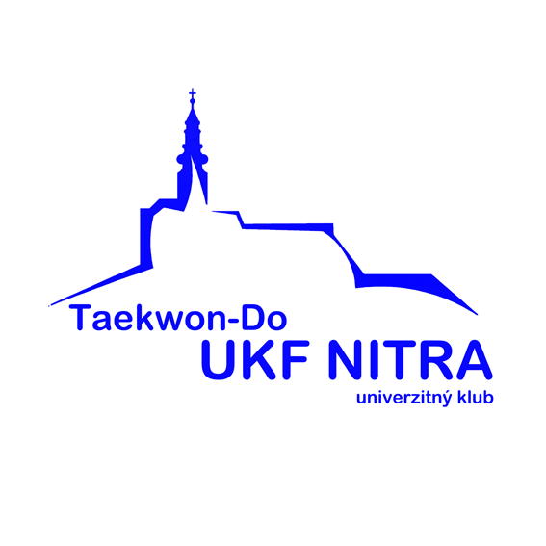

COMPETITORS:
Name and surname | Sex  M/F | Youth/  Junior/  Senior | Kup /  / Dan | Pattern  Y / N | Sparring  kg** | Team tul  Y / N | Hosinsool | Power break.  Y/N

Send this Application form before the deadline - Sunday April 4 till 18.00!

E-mail: tkd.ukf@centrum.sk

