www.tkd-klub-radovljica.si



Dear President,
Dear Instructors,
Dear Friends,

We are honored to invite You on 2nd OPEN SLOVENIA – GORENJSKA – PRESIDENTIAL CUP that will be held in RADOVLJICA – SLOVENIA 08. October 2005.
We will do our best to meet Your expectations and make this sport event enjoyable for everyone.

In the case You have any questions do not hesitate and call us as soon as possible on mobil phone ++386 41 350 351 and fax ++ 386 45 315 270  Zeljko | e-mail: zeljko.gvozdic@siol.net

2nd OPEN SLOVENIA – GORENJSKA

PRESIDENTIAL CUP

Competition will be performed for:

YOUTH – MALE AND FEMALE UP TO 13 YEARS ( the oldest year 1992)
JUNIORS – MALE AND FEMALE AMONG 13 AND 17 YEARS ( the oldest year1988)
SENIORS - MALE AND FEMALE 18 YEARS AND ABOVE ( the youngest year 1987)

Year of birth will be recognized from the passport at the time of weight in performance.

Place : Sport Hall in Radovljica – Guest secondary school ( Srednja gostinska šola )
Organizer : TAEKWON-DO CLUB »RADOVLJICA« Radovljica
Fee: 15,00 EUR, paid on the day of the tournament

SPARRING:
Juniors up to 13 years ( the oldest year 1991)
Male: -25 kg , -30 kg , - 35 kg , - 40 kg , - 45 kg , - 50 kg , -55 kg , + 55 kg
Female: - 25 kg , - 30 kg , - 35 kg , - 40 kg , - 45 kg , - 50 kg , - 55 kg ,+55 kg
Juniors among 13 and 17 years ( the oldest year 1987 )
Male: - 52 kg , - 58 kg , - 63 kg , - 70 kg , + 70 kg
Female: - 42 kg , - 48 kg , - 53 kg , - 60 kg , + 60 kg

Seniors : the youngest year 1986
Male : - 54 kg , - 63 kg , -71 kg , - 80 kg , + 80 kg
Female : - 52 kg , - 58 kg , - 63 kg , - 70 kg , + 70 kg

Sparring
Duration: Qualifications: 1 x 3 minutes
Finals : 2 x 2 minutes

SAFETY:
Under 13 years are not requested to wear a groin guard, but any male
over 13 years MUST wear a groin guard. Macho gloves are allowed for under 13
years, but only closed fingers ( not boxing gloves ) gloves will be allowed
for over 13 years.

Patterns :
yellow belte: from Chong Ji to Dan Gun
green belts: from Chong Ji to Won Hyo
blue belts: from Chong Ji to Joon Gun
red belts: from Chong Ji to Hwa Rang
black belts 1st dan from Chong Ji to Ge Baek
black belts 2nd dan from Chong Ji to Ju Che
black belts 3th dan from Chong Ji to Choi Yong

In qualification : the Jury designates the TULL
In finals : compeetitors must perform one optional and one designated

Excessive contact WILL NOT be tolerated, so please prepare your students appropriately.

Entries
Deadline: 22. 09. 2005

Rules: It will be held according to the rules and regulations of ITF.
Referees: Every club must provide 1 ( one ) referee.The club that attends to come without
referee must inform the organizer and pay 50 EUR on the day of the turnament .

The organizer will provide full board and WAGES for one referee from each club.Umpires are allowed to wear ONLY the official umpire outfit ( blue jacket, white long sleeved shirt, blue tie, blue pants, white sport shoes and white socks.
Coaches : must wear training suits and running shoes. Only one coach is allowed in the
competitor area.
Draft : Draft will be performed on September 30. 09. 2005
Weight
checking : For competitors from foreign countries weight in will be performed on Friday,
October, 07th 2005 from 15:00 to 22:00 hour in Sport Hall in Radovljica.

Any participant overweighing division limit will be refused to participate = will be
disqualified
The official protest note must be written in 5 minutes after sparring and get to the
Jury. President after paying an amount of 50 EUR to organizers official.
Only coaches are allowed to present an official protest.

Sparring
Equipment :
All participants must wear official ITF dobok and protecting equipment
according to ITF rules.

Each competitor will compete on his own risk.

Prizes:
Medals will be awarding for:
1st , 2nd and 2 x 3rd place individuals
Specials awards for:

BEST M. and F. YOUTH
BEST M. and F. JUNIOR
BEST M. and F. SENIOR

AND

1st , 2nd and 3rd place for the best clubs

Informations :
All informations you can get on following :
Phone :++38645315270

Fax: ++38645315270
Mobil phone:++38641350351
e-mail: zeljko.gvozdic@siol.net

Schedule of event on Saturday , October 08th 2005:

08:00 – 09:00 Weight in
09:00 – 09:30 Referee and instrctors meeting
09:30 - 10:00 Opening ceremony
10:00 Competition start
After qualifications will following Finals

HOW TO ARRIVE TO RADOVLJICA

The Municipality of Radovljica covers the area between the Karavanke in the north and Jelovica in the south.The Sava Bohinjka and the Sava Dolinka flow here into the Sava.The area to the left of the river is a sunny plain with settlements, fieds and meadows. The administrative center and the only town is Radovljica, which has kept its medieval town centre. It is known for the Museum of Apiculture and summer festival of old music. To the east, there is Brezje, the most important Slovenian pilgrimage with St.Mary s Basilica. Begunje is located under a high mountain calld Begunjščica ( 2066 m ). It is a pleasent tourist village with a magnificent manor and ruins of the old castle. It is the birthplace of Vilko and Slavko Avsenik, who are the founders of the most successful Slovenian folk music group, well known also abroad. Lesce, located in the west, boast one of the most beautiful tourist camps Šobec, a sports airfield, hippodrme and a golf course. The right bank of the Sava below Jevovica was characterised by iron working in the past.Kropa with the Iron Forging Museum and Kamna Gorica are preserved from the times of foundries.

There is international airport Ljubljana – Brnik which is only 25 kilometres east from Radovljica. If you inform us about your arrival in time or phone us from the airport we can provide transport to Radovljica for you.
However, if you are going to drive, you ll have to follow the local road ( direction Austria – Kranjska Gora – Jesenice), get on the motorway ( same direction ) and take the exit at Radovljica.
From east you are going by car Slavonski Brod – Zagreb – Ljubljana – Kranj – Radovljica.

BLED (1099 year) captured the world's attention when Dr. Arnold Rikli, a Swiss homeopath, discovered
the therapeutic waters 145 years ago. Already an important centre of attraction, Bled has traditionally
drawn royalty, politicians, art lovers and sportsmen from different parts of the globe.
Aside from the healing powers of the spa. Bled is an ideal vacation spot which offers a particular
wealth of sporting activities such as rowing in Zaka; a popular rowing center used for world
championships, golf in a 27-hole Master's course, excellent skiing conditions and ice skating on the
frozen lake...
Travellers can also visit Bled's medieval farmhouses, majestic castles and churches. Among them are the Church of Sta. Maria situated on an island in the middle of the lake, where the wishing bell is heard ringing across the waters, represents Bled's unique sight, reached by 'p/etna'- traditional
manually operated boat.
'Slovenian only Island is not far from the Sea...'
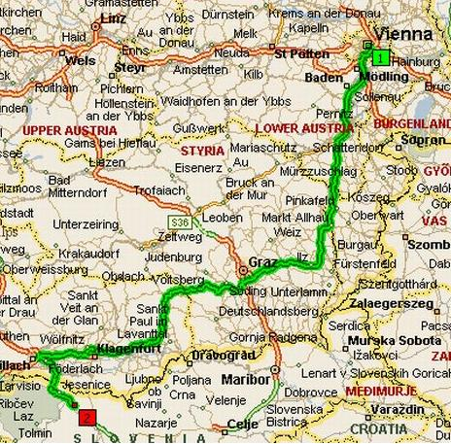
Vienna - Radovljica

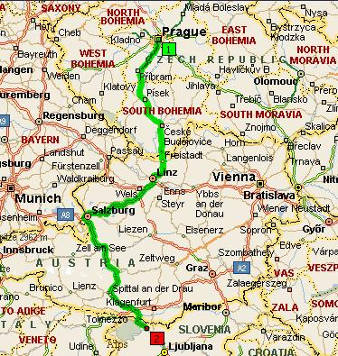
Prague - Radovljica
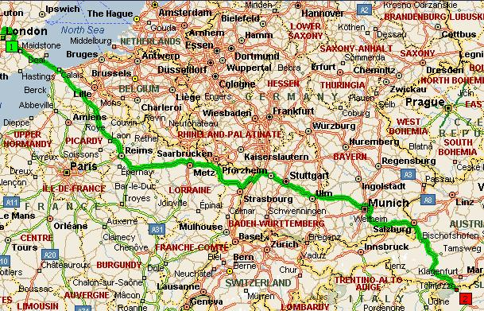
London – Paris - Radovljica

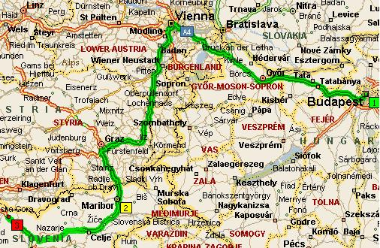
Budapest - Radovljica
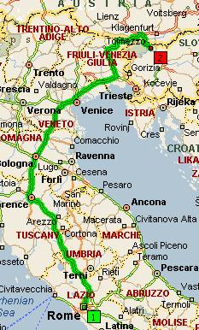
Rome - Radovljica

ACCOMMONDATION

As for accomodation there is a choice of hotels in Radovljica from three – star to five –star luxury hotels.
We are offering in a three – star hotel » CASTLE« Radovljica: - two-bed and breakfast for 22 EUR
- half board for 28 EUR
- full board for 34 EUR

We are offering in a five –star hotel » KOMPAS » Bled :- two-bed and breakfast for 78 EUR
- every additional meal is 10 EUR

Because of turistic top season please send your application form not later than 22. 09. 2005.

You are welcome to come to the competition and take a look at the beautiful town of Radovljica and Bled which is beautiful lake and one of the candidate town for the organization of the 15th World Senior Championship 2007.

Welcome in Slovenia !

Yours in Taekwon-Do,

Željko Gvozdič, 5. DAN
Main referee

Organizing Committee

2nd Open Slovenia - Gorenjska

Dr. Bojan Potočnik

